Name of Student : Raghav Mahesh Sarda PRN: 25070122235
Subject: Programming with Java Semester: III
ASSIGNMENT No : 7 Year: AY 2026-27
TITLE : Inheritance and Interfaces

Problem Statement
Implement a Java program to demonstrate inheritance and interfaces using suitable real-world examples.

Learning Objectives
To implement inheritance and interfaces for achieving code reusability and abstraction.

Program:
ShapeApplication.java
// Assignment 7 - Exercise 1: Shape application using Inheritance and Interfaces
import java.util.*;
interface Drawable // Interface demonstration for abstraction
{
void draw(); // Abstract method to be implemented by child classes
}

class Shape // Parent class demonstrating inheritance
{
String color;
Shape(String c) // Parent constructor
{
color=c;
}
}

class Circle extends Shape implements Drawable // Inheriting Shape and implementing Drawable
{
double r; // Radius
Circle(String c, double rad) // Child constructor
{
super(c); // Calling parent constructor to set color
r=rad; // Assigning radius
}

public void draw() // Overriding interface method
{
System.out.println("Drawing a " + color + " Circle.");
System.out.println("Area = " + (3.14*r*r));
}
}

class Rectangle extends Shape implements Drawable // Inheriting Shape and implementing Drawable
{
double l, b;
Rectangle(String c, double len, double bre) // Child constructor
{
super(c); // Calling parent constructor to set color
l=len;
b=bre;
}

public void draw() // Overriding interface method
{
System.out.println("Drawing a " + color + " Rectangle.");
System.out.println("Area = " + (l*b));
}
}

public class ShapeApplication
{
public static void main(String args[]) // Main Method
{
Scanner sc = new Scanner(System.in);
System.out.println("Enter Circle Details: ");
System.out.print("Colour: ");
String cc = sc.next();
System.out.print("Radius: ");
double cr = sc.nextDouble();

System.out.println("");
System.out.println("Enter Rectangle Details: ");
System.out.print("Colour: ");
String rc = sc.next();
System.out.print("Length: ");
double rl = sc.nextDouble();
System.out.print("Breadth: ");
double rb = sc.nextDouble();

Circle c = new Circle(cc, cr); // Object creation for Circle
Rectangle r = new Rectangle(rc, rl, rb); // Object creation for Rectangle

System.out.println("");
c.draw(); // Calling circle method
System.out.println("");
r.draw(); // Calling rectangle method

sc.close();
}
}

ECommerceProductSystem.java
// Assignment 7 - Exercise 2: E-Commerce Product System using Inheritance and Interfaces
import java.util.*;
interface Billable // Interface for product actions
{
void generateBill(); // Abstract method for billing
}

class Product // Parent class for common properties
{
String name;
double price;
Product(String n, double p) // Constructor
{
name=n;
price=p;
}
}

class Electronic extends Product implements Billable // Inheriting Product and implementing Billable
{
int warranty; // Specific property for electronics
Electronic(String n, double p, int w) // Constructor
{
super(n,p); // Parent initialization for name and price
warranty=w;
}
public void generateBill() // Implementing interface method
{
System.out.println("Electronic: " + name + " | Price: $" + price + " | Warranty: " + warranty + " months");
}
}

class Clothing extends Product implements Billable // Inheriting Product and implementing Billable
{
String size;
Clothing(String n, double p, String s) // Constructor
{
super(n,p); // Parent initialization for name and price
size=s;
}
public void generateBill() // Implementing interface method
{
System.out.println("Clothing: " + name + " | Price: $" + price + " | Size: " + size);
}
}

class Grocery extends Product implements Billable // Inheriting Product and implementing Billable
{
String expiry;

Grocery(String n, double p, String e) // Constructor
{
super(n, p); // Parent initialization for name and price
expiry = e;
}
public void generateBill() // Implementing interface method
{
System.out.println("Grocery: " + name + " | Price: $" + price + " | Expiry: " + expiry);
}
}

public class ECommerceProductSystem
{
public static void main(String args[]) // Main method
{
Scanner sc = new Scanner(System.in);

System.out.println("Enter Laptop Details: ");
System.out.print("Name: ");
String en = sc.nextLine();
System.out.print("Price: ");
double ep = sc.nextDouble();
System.out.print("Warranty (Months): ");
int ew = sc.nextInt();

System.out.println("");
System.out.println("Enter T-Shirt Details: ");
System.out.print("Name: ");
String cn = sc.next();
System.out.print("Price: ");
double cp = sc.nextDouble();
System.out.print("Size: ");
String cs = sc.next();

System.out.println("");
System.out.println("Enter Milk Details: ");
System.out.print("Brand: ");
String gn = sc.next();
System.out.print("Price: ");
double gp = sc.nextDouble();
System.out.print("Expiry Date: ");
String ge = sc.next();

Electronic e = new Electronic(en, ep, ew); // Electronic object creation
Clothing c = new Clothing(cn, cp, cs); // Clothing object creation
Grocery g = new Grocery(gn, gp, ge); // Grocery object creation

System.out.println("");
System.out.println("\n- E-Commerce Bill -");
e.generateBill(); // Calling electronic billing
c.generateBill(); // Calling clothing billing
g.generateBill(); // Calling grocery billing

sc.close();
}
}

Output:
ShapeApplication.java
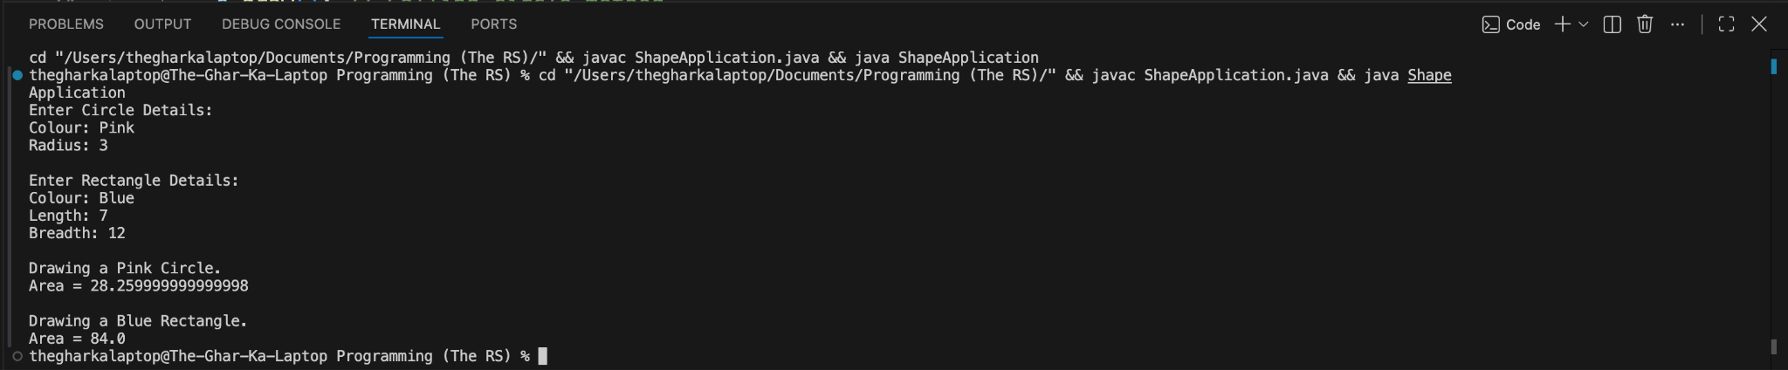

ECommerceProductSystem.java
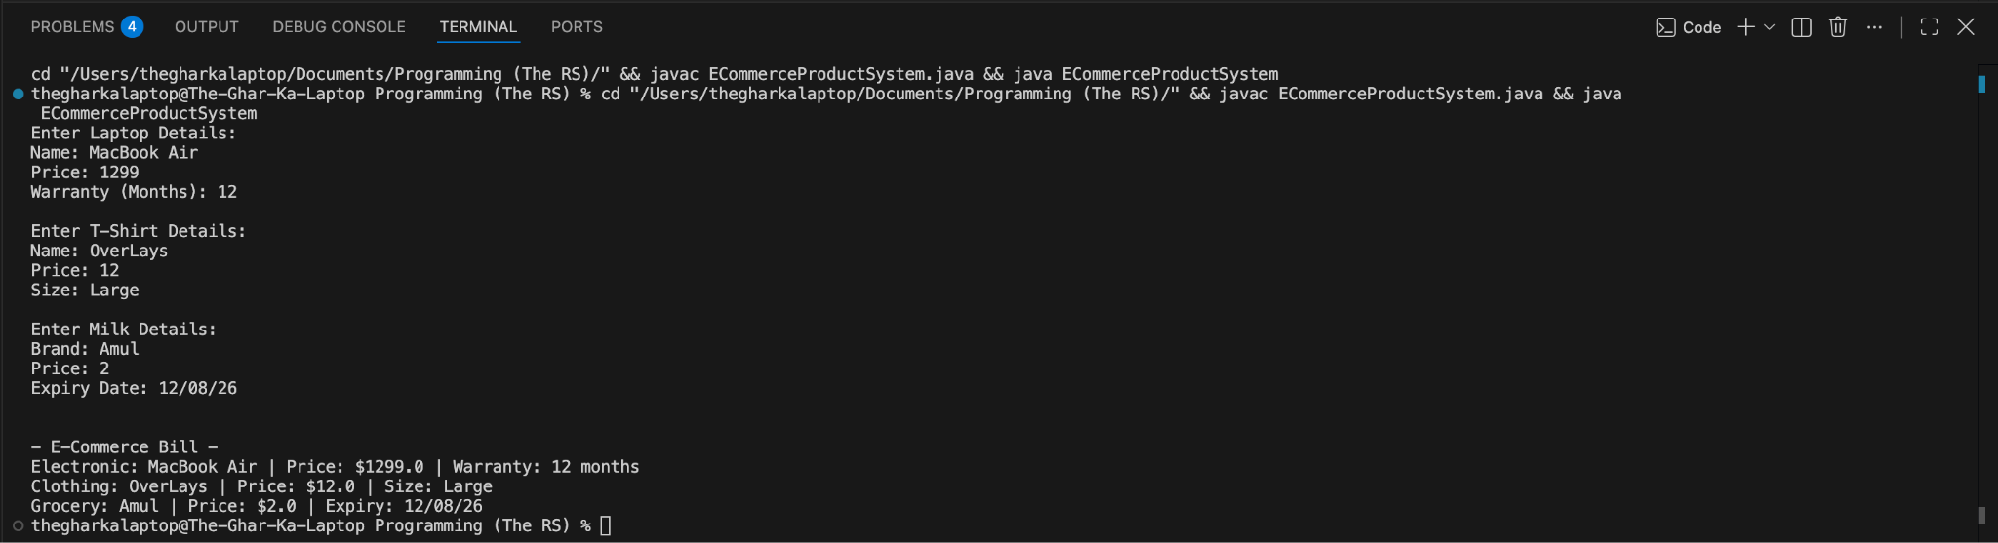

Conclusion:
In this assignment, concepts of code reusability and abstraction using inheritance and interfaces were successfully implemented and verified. Inheritance allowed child classes to dynamically acquire common properties from a parent class, significantly reducing code redundancy, while interfaces established a strict contract for required methods across diverse classes.

